# Задание 1

x1 = 1 x2 = 7 λ = x1 (c-1) pk(t) = ((λt)k / k!) * e-λt

k = 0 t = x2 (c) pk(x2) = ((x1 * x2)0 / 0!) * e-3*x2 ≈ 7.58×10−8

# Задание 2

| λ = x1 (c-1) t = x2 (c)  pk(t) = ((λt)k / k!) * e-λt = (3k / k!) * e-3 | |  | λ = x2 (c-1) t = 0,01 (c)  pk(t) = ((λt)k / k!) * e-λt = (0,01k / k!) * e-  0,01 | |
| --- | --- | --- | --- | --- |
| k | p |  | k | p |
| 0 | 0.000911882 | 0 | 0.932394 |
| 1 | 0.00638317 | 1 | 0.0652676 |
| 2 | 0.0223411 | 2 | 0.00228436 |
| 3 | 0.0521293 | 3 | 5.33018e-05 |
| 4 | 0.0912262 | 4 | 9.32782e-07 |
| 5 | 0.127717 | 5 | 1.3059e-08 |
| 6 | 0.149003 | 6 | 1.52354e-10 |
| 7 | 0.149003 | 7 | 1.52354e-12 |
| 8 | 0.130377 | 8 | 1.52354e-12 |
| 9 | 0.101405 | 9 | 1.03686e-16 |
| 10 | 0.0709833 | 10 | 7.258e-19 |
|  | Pmax = 0.149003 |  |  | Pmax = 0.932394 |

# 

График:

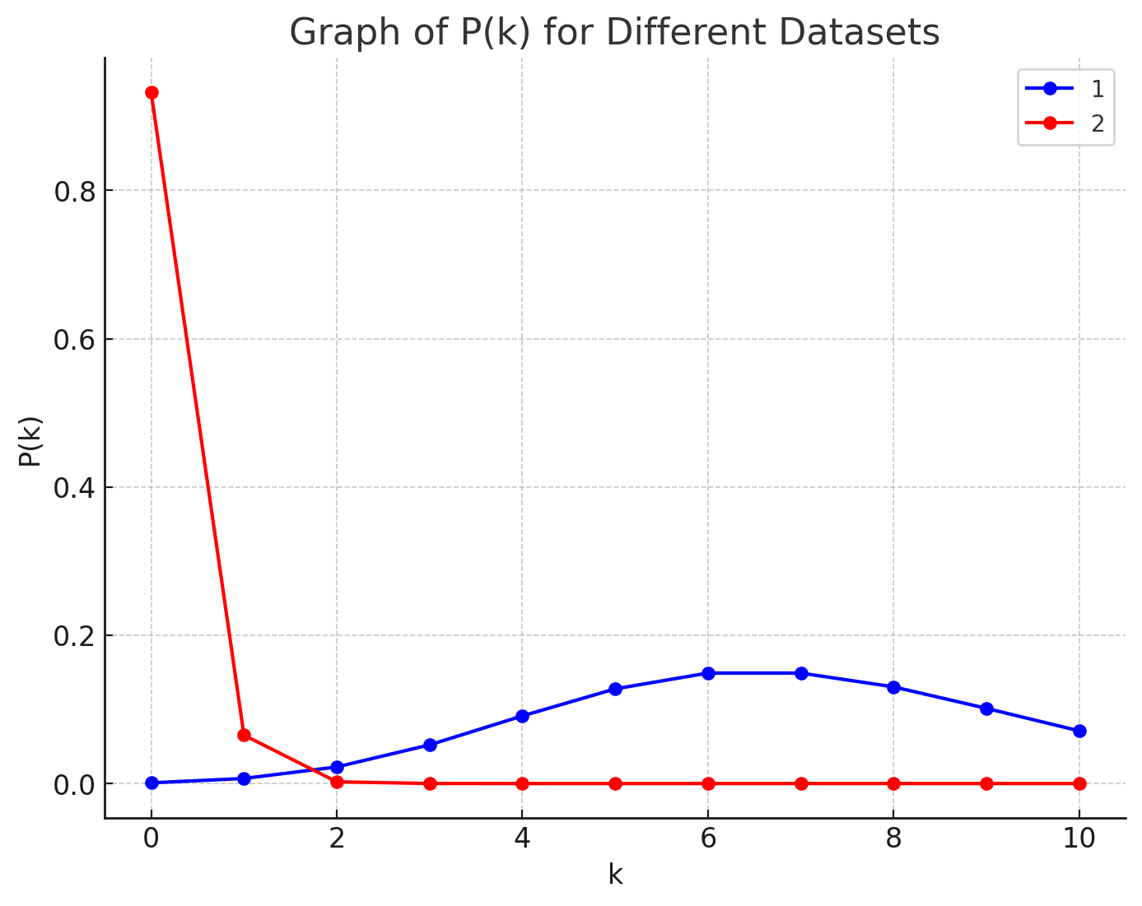

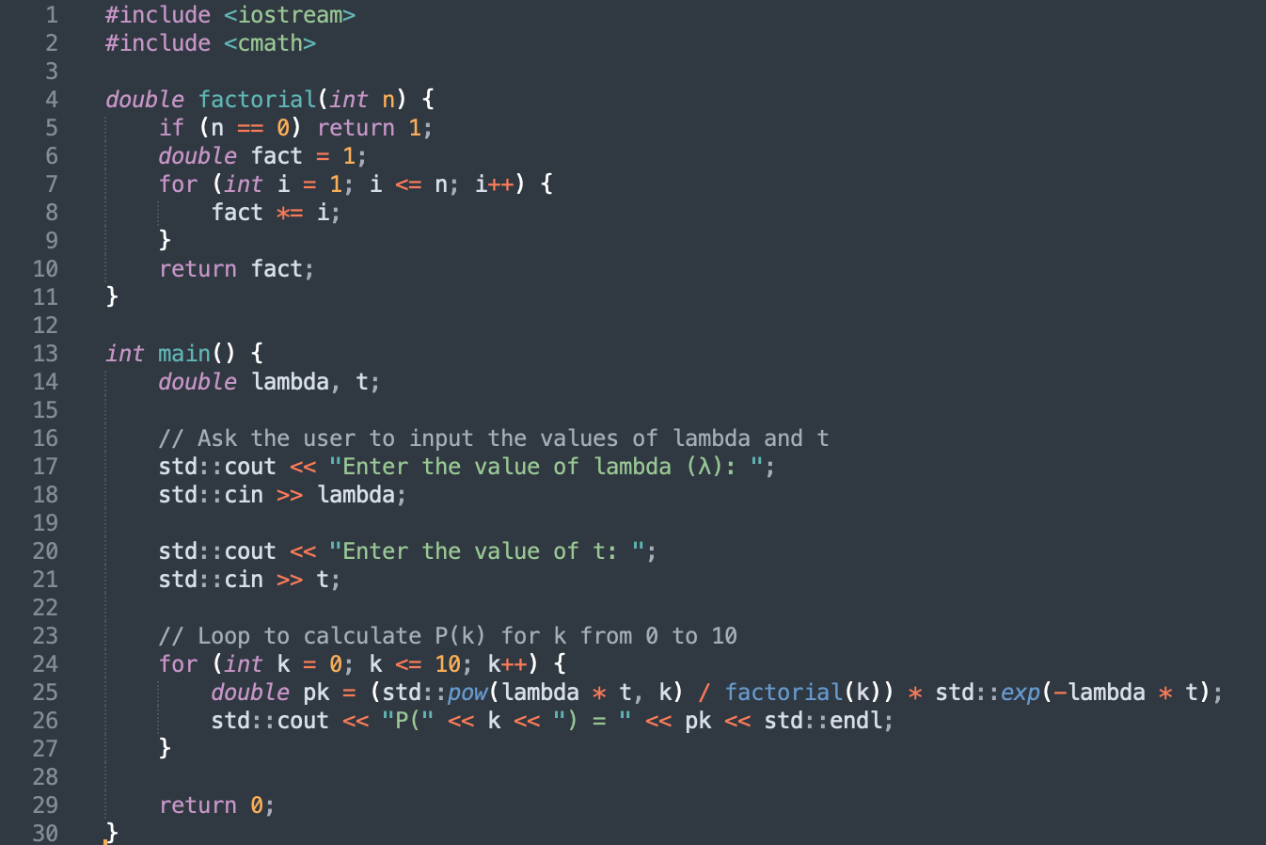

# Задание 3

h(t) = 1 – e-µt

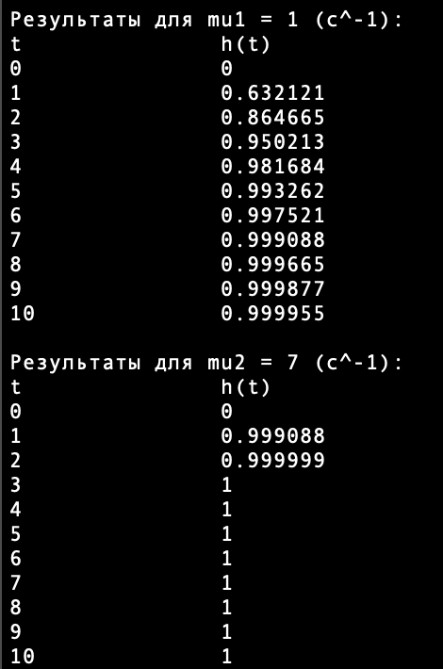

График:

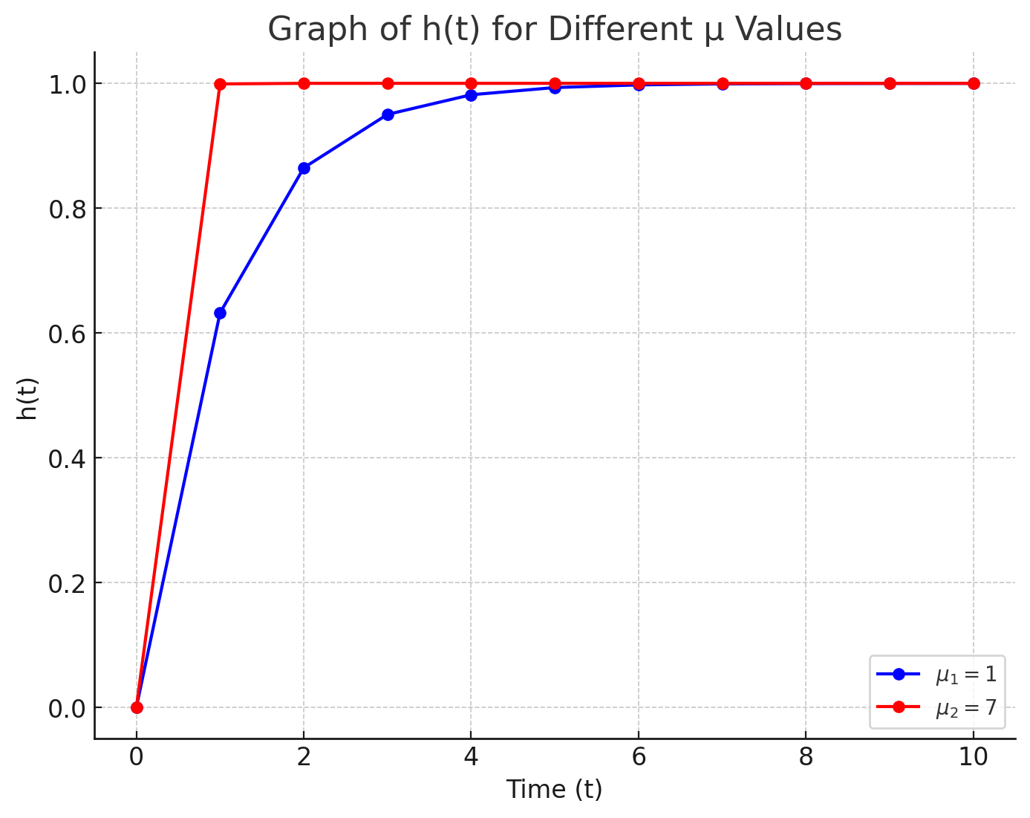

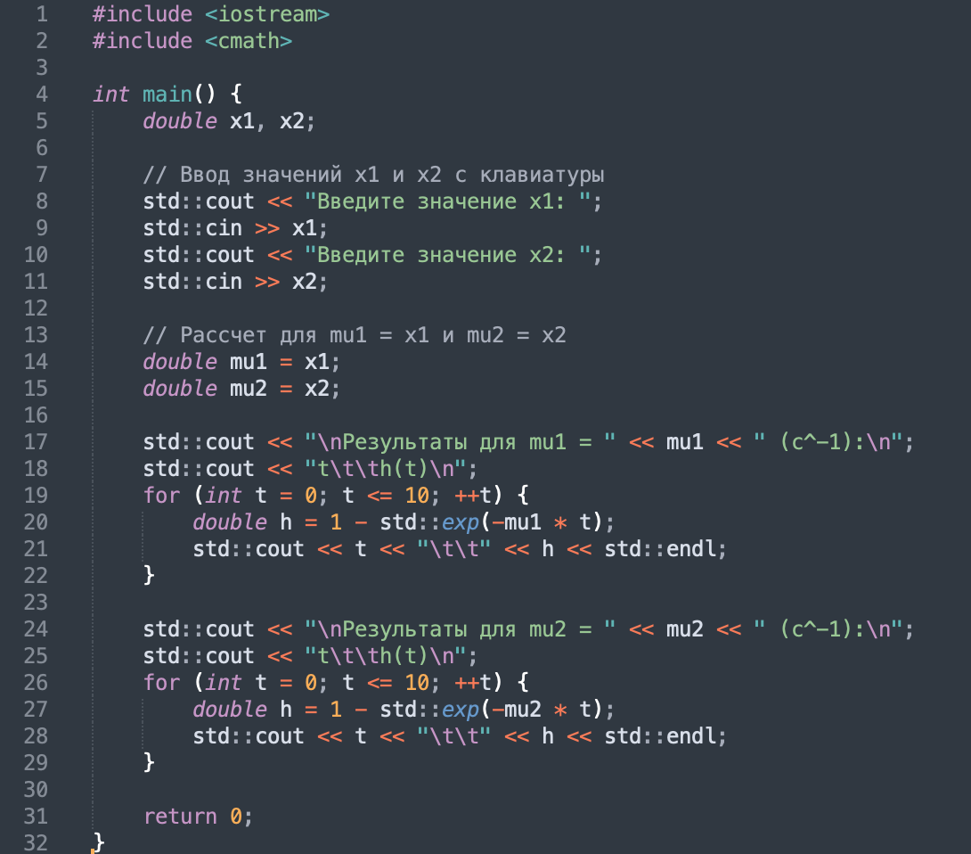

# Задание 4

| pk(t) = ((λt)k / k!) * e-λt | | |
| --- | --- | --- |
| k = 20 + x1 + x2 | t = x1 / 100 | λ = x2 (c-1) |
|  | pk(t) = 0,0124 |  |

Исходный код (С):

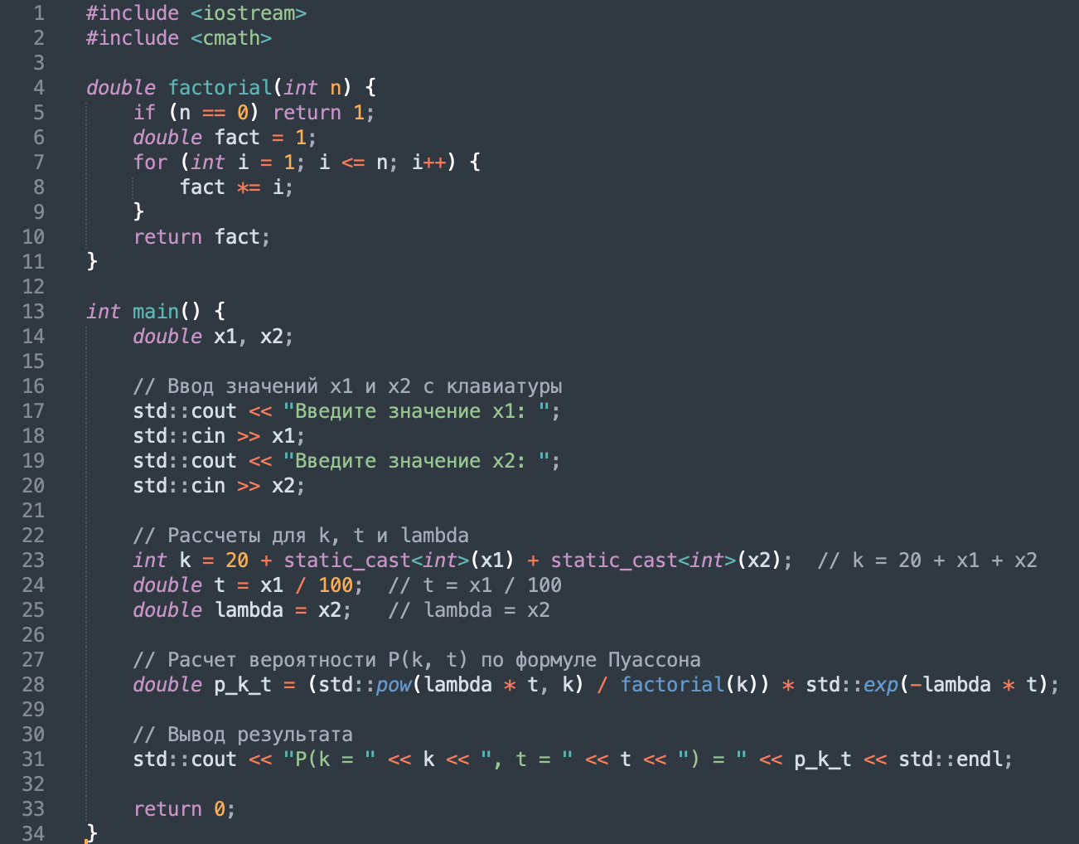

Вывод:

